*Job order:*

**ORI20001**

*Customer:*

**ITA ELECTRIC SRL**

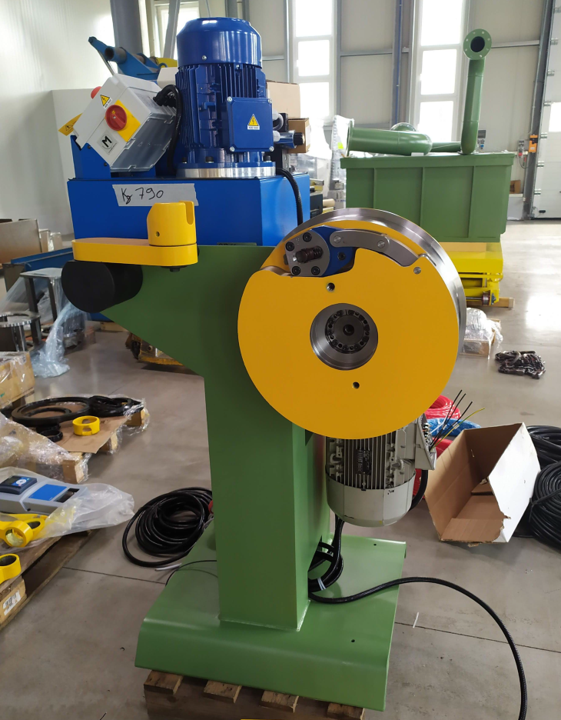

Machine Model: **WIRE POINTING MACHINE – AP**

1 INTRODUCTION

1.1 GENERAL INTRODUCTION 1

2 IDENTIFICATION & TECHNICAL DATA

2.1 IDENTIFICATION 4

3 FOUNDATIONS, LIFTING & INSTALLATION

3.1 FOUNDATIONS 4

3.2 LIFTING & INSTALLATION

3.2.1 General Recommendations 4

3.2.2 Pointing Machine Frame 6

3.3 MACHINE CONNECTIONS

3.3.1 Electrical Connections 6

4 START-UP

4.1 GENERAL PRECAUTIONS 7

4.2 POSSIBLE EMERGENCIES 7

4.3 PRELIMINARY CHECKS 7

4.4 ROTATION OF THE MOTOR 8

4.5 RUNNING-IN 8

4.6 STARTING THE MACHINE 8

5 OPERATING INSTRUCTIONS

5.1 POINTING THE WIRE 9

5.2 RUNNING THE PULLING HEAD & TONGS 9

6 SPECIFICATIONS

6.1 AP – WIRE POINTING MACHINE 10

6.2 GENERAL DATA 10

6.3 CONTROL PANEL 10

7 MACHINE MAINTENANCE

7.1 GENERAL RECOMMANDATIONS 11

7.2 ELECTRICAL EQUIPMENT 11

7.3 MACHINE LUBRICATION 12

8 SPARE PARTS

8.1 GENERAL REMARKS 14

8.1.1 Mechanical components 14

9 PHOTOS 15

10 DRAWINGS 16

* 1. **INTRODUCTION**
  2. **GENERAL INTRODUCTION**

It is recommended that this manual be read with care and that the instructions herein be followed scrupulously.

This instruction manual describes and explains only the ordinary installation, running and maintenance operations. If extensive repairs or overhauls should ever become necessary, consult RIZZARDI INTERNATIONAL.

A copy of the electrical diagrams is sent inside the electrical cabinet. A further copy is included with this manual. When relevant, copies of transmission diagrams and pneumatic, fluid and/or hydraulic diagrams are also included with this manual.

The terms used to locate various components or define the direction of rotation are always intended to mean with the operator facing the machine or line.

For any communication, always refer to the identification numbers, which are stamped on metal plates attached to the machine or line units.

When requesting technical assistance or when ordering spare parts, it is strongly recommended that reference also be made to the code number, the work order number and the description, to avoid the possibility of errors or confusion.

When referring to the electrical, pneumatic and/or hydraulic equipment, also specify the number of the diagram series.

When replacing machine or line components, **original spare parts** should be procured directly from RIZZARDI INTERNATIONAL. The use of non-original spare parts could constitute a source of danger to the persons involved and/or could cause damage to the machine or line and/or to the functioning thereof.

To avoid errors in delivery, delays or other inconveniences, we recommend the use of the **ITALIAN** or **ENGLISH** language for all communications.

RIZZARDI INTERNATIONAL equipment is supplied precabled, tested and partially run-in at our factory.

The modalities for technical assistance and warranty are covered by the official sales documents pertaining to the machine or line, which are binding under any circumstances.

|  |
| --- |
| **Prevention of Accidents**  To prevent accidents**:**  - **Do not** remove or substitute the mechanical guards or electrical protections.  - **Do not** touch any of the machine or line organs when they are moving.  - **Do not** start up the machine or line if the grounding connections are not perfectly efficient.  - **Turn** the main switch of the electrical cabinet to **0/OFF** before doing any machine or line maintenance; and disconnect the cabinet from the electrical mains before doing any maintenance on the electrical cabinet.  In case of electrical trouble-shooting, because it is necessary to work with the voltage on, the operator must be experienced or, at least, informed about the risks.  - **Put up** danger and/or repair signs wherever the process movements or materials could cause accidents to ***Exposed Persons***.  - **Never use water** to put out fires that might occur on or near the machine or line.  **It is forbidden** to allow the machine or line to be operated by persons who are not instructed or advised in its use.  A copy of this manual must be given to the operators authorized to run and maintain the machine or line, or in any case kept near the machine or line to facilitate consultation. |

**Make sure to carefully** inspect all equipment upon receipt or, in any case, before installation, to make sure no damage has occurred during shipping. If damage is found, it should be reported immediately to RIZZARDI INTERNATIONAL.

No responsibility can be attributed to RIZZARDI INTERNATIONAL for damages of any type deriving directly or indirectly from**:**

* Installation or start-up of equipment that has been damaged during transport
* Non-observance of the instructions in this manual
* In any case, improper or unauthorized use of the machine or line

use of unsuitable or non-original spare parts.

|  |
| --- |
| **Demolition and Disposal**  Most of the construction components of the machine or line subject of this manual are made of painted metal plate. In case of demolition, these components can be disposed of through normal channels, in accordance with local legislation.  Potentially dangerous or polluting components or substances used for construction, operation or maintenance of the machine or line must be consigned to authorized collection centers or companies specialized in the disposal of harmful or polluting materials, in accordance with local legislation. Such materials consist of**:**  - lubricating greases and oils  - oil for hydraulic plants  - brake pads  - scale and dust deriving from production process  - cathode ray tubes used in PC screens  - batteries  - copper by-products  - electrolytic condensers  - pressurized containers (such as electrical cabinet air conditioners).  The machine or line identification plates should also be destroyed, together with all related documentation. |

**2.0 IDENTIFICATION**

# 2.1 IDENTIFICATION

Each piece of equipment supplied by RIZZARDI INTERNATIONAL has a metal plate attached to it containing the identification information.

**3.0 FOUNDATIONS, LIFTING AND INSTALLATION**

### **FOUNDATIONS**

The machine does not require special foundations. It can be installed on an ordinary, level pavement that is suitable for the weight of the machine itself.

# 3.2 LIFTING & INSTALLATION

## General Recommendations

Operators entrusted with lifting operations must be fully aware of the specific risks to which they or others may be exposed. Such operators must have suitable experience in the use of lifting and transport equipment.

The user must make sure the operators are fully aware of the instructions herein and arrange for sufficient supervision to ensure that the lifting operations are carried out respecting general safety regulations.

The machine should be lifted with a crane and lifting cables, with a fork lift truck or manually, depending on the dimensions.

Unless otherwise indicated, suitably strong metal or fiber lifting cables should be used, also bearing in mind the angle of the lifting zones.

If the weight is not evenly distributed, a single cable must be strong enough to support the weight, while the other cables stabilize the load.

The use of a balance is recommended if the shape or dimensions of the unit or machine makes it impossible to lift it with cables converging at a single point.

The cables must be positioned securely at the bottom of the lifting hook.

Make sure to adjust the length of the lifting cables so that the structures are in equilibrium. Check the equilibrium by lifting the load slowly at first, and just a few centimeters off the ground.

If the size of the load prevents the operators from having a full view during lifting and moving operations, other personnel must be available to assist with signals or other indications.

Parts that are likely to find themselves in the path of the lifting cables must be protected from possible damage by contact. During lifting and moving also be careful not to damage any protruding parts.

**IMPORTANT NOTICE**

**It is extremely dangerous and therefore it is important to avoid:**

- shortening the cables by making knots in them

- positioning cables on the point of the lifting hooks

- using the bill of the hooks

- overlapping the cables, crossing them over on the lifting hook

- lifting structures without using the lifting devices provided for this purpose (eyebolts, specific holes, etc.) where foreseen

- guiding a suspended load manually; it must be guided only with cables and hooks

- passing a suspended load over the heads of people; if it cannot be avoided, it must first be announced with appropriate signals.

**3.2.2 Wire Pointing Machine Frame**

Lift the wire pointing machine with forklift starting very slowly to ascertain that the load is properly distributed. Adjust positioning of forks if necessary.

Carefully lower the frame in the floor

**3.3 MACHINE CONNECTIONS**

**3.3.1 Electric Connections**

Connections between the machine and control console must be made with suitably sized cables to avoid voltage drops due to the length of the cables themselves. Unless otherwise specified, the section of terminal connectors should measure at least 1.5 mm². Where expressly indicated in the electrical diagrams, use screened cables.

Notes:

Electrical cables for cabinet-to-network connections are not included in the supply.

**4.0 START - UP**

## 4.1 General Precautions

1. Never lean on driving units.
2. Do not use the machine for purposes other than those foreseen by the manufacturer.
3. Always make sure beforehand that no harm to persons or property will result from the operation of the machine or any of its units.
4. Before performing any function, mark off the work area and use all personal safety devices warranted. Be sure to comply in any case with existing safety and health regulations.
5. Carefully check all security systems before start-up.
6. **ONLY THE MANUFACTURER SHOULD BE CONTACTED IN CASE OF AN ANOMALY.**
7. After an emergency stop, do not reset the productive cycle until the peril or anomaly is over.

## 4.2 Possible Emergencies

Timeliness is of the essence in cases of emergencies that arise during operation due to machine malfunction, processing problems, maintenance, etc. or due to external causes.

***WARNING: in the event of an operator-induced or automatic emergency stop the power supply to the electric cabinet terminals is not cut off. If necessary, use the main switch to cut the power.***

## 4.3 Preliminary Checks

For safety purposes, the machine must never be used before making sure that:

1. all control stations and command buttons are readily accessible
2. all electrical interconnections are correctly made
3. all symbols, warnings and plates on the machine are undamaged and clearly legible
4. all safety devices are in working order

**WARNING:** ***never*** start the machine if an anomaly is detected. Switch the power supply off and contact the manufacturer.

## 4.4 Rotation of the Motor

After having switched on the general power supply and prepared the machine for start-up, first check the direction of rotation of the pointing rolls and then of the pulling head, as follows:

pulling head  
The pulling head with threading tong can rotate in either direction. Use the selector switch to set the chosen direction. In any case, the head rotates counterclockwise in winding mode (see sketch below).



WIRE

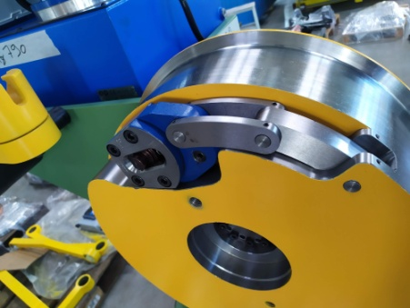

The motor is controlled by an inverter. Use the potentiometer on the panel of the electric cabinet to set and adjust winding speed.

## 4.5 Running-in

During the first hours of operation avoid operating the machine at full load and at full speed. This will allow time to break in all the components.

During this time, carefully observe all the machine units to make sure they are operating correctly.

## 4.6 Starting the Machine

1. Make sure the electric cabinet panel door is closed.
2. Turn the main switch of the cabinet panel to I.

The machine is now ready to perform all its functions by means of the following commands:

Pulling head: FORWARD/REVERSE selector

Drive pedal

**5 OPERATING INSTRUCTIONS**

## 5.1 Pointing the Wire

1. To point the wire, use hydraulic press. (refer to hydraulic press manual for instructions and maintenance)
2. Insert the proper die set (machine is provided with 3 set of dies: 10 – 12 – 14mm, others measures from 10 up to 25mm can be provided upon request).
3. Rotate the wire and activate and press it many times to obtain round section.
4. Once the wire can be putted into the required drawing die, proceed with next step: die stringing-up

## 5.2 Running the Pulling Head & Tongs

1. Position the pull-in dog
2. Insert the die in its seat
3. Pass the pointed end of the wire through the die
4. Hook the wire to the pull-in dog
5. Tension the wire and check that the tong is well clamped
6. Wind wire on the head to the desired filling height.

**6 SPECIFICATIONS**

**6.1 Ap - Wire Pointing Machine**

- Range of FLAT wire

- Range of wire aluminium 15.0 mm - 10,00 mm

- Capstan 450 mm

- Main gearbox Make STM

Code EXB 303 PN2 CM24 i=52.4

* Main motor Make SIEMENS

Type 132M IMB5 7,5kW 4 poles

* Hydraulic press Make OP

Type H83/E EL

Power 3 kW

Oil required Hydraulic oil 46cSt @ 40°C

Qty 30 lt not included

***Important:*** the gearbox is provided EMPTY, before starting up the machine, the tanks should be filled with oil MOBILGEAR 630 or comparative

**Colours:**

• Machine external colour Green RAL 6011

* Rotating parts Yellow RAL 2003
* electrical cabinet Gray RAL 7035
* OEM as provided form producer

## 6.2 General Data

• Supply voltage: 400 V+/-10%-50Hz-3phase+/- 2%

• Emergency stop: immediately

**6.3 Control Panels**

**Control panel is integrated in the main power inverter, refer to electrical schemes**

**7.0 MAINTENANCE & LUBRICATION**

**7.1 GENERAL RECOMMENDATIONS**

Systematic, programmed maintenance is a determining factor in the life of a machine.

However, standard maintenance intervals are indicative at best as they can vary from machine to machine and also depend on working and environmental conditions. We therefore strongly recommend that users keep a record of interventions and replacements to customize their maintenance and spare part stocking schedules.

**important notice**

Maintenance must be carried out by ***qualified operators*** who are aware of current safety regulations and have been adequately instructed in the use of the machines, or have at least been duly informed about them. Incorrect performance of maintenance operations is potentially dangerous to the persons involved and can also damage the machines, so it is sound practice to arrange *in any case* for a technical supervisor to verify that the operator observes the following rules:

* review beforehand the technical data and specifications of the machine
* use protective clothing and equipment
* make correct use of tools, lifting and moving equipment
* keep non-qualified or extraneous persons away from danger zones or operating areas during maintenance.

**7.2 Electrical Equipment**

This equipment requires no maintenance as such. In case any components have to be replaced, the complete list is included with the electrical diagrams.

It should be noted that the electrical equipment has been designed to precise specifications, for the use intended.

The drives are constructed with integrated circuits, semiconductors and other solid-state components, such as thyristors, diodes, etc. supplied by well-known international manufacturers, carefully chosen by the supplier and tested in our laboratories. Furthermore, the drives are dry and load-tested on the machine prior to shipment.

Nevertheless, it may happen that some of the electronic components on the cards prove to be defective within the first 200 to 500 hours of machine operation. These cases are statistically negligible, but can occur, and in fact are designated in electronic slang as cases of "infant mortality". The fault is corrected simply by substituting any cards which prove to be defective, obviously at the expense of the manufacturer. In this case, the defective card or cards must be returned to the manufacturer for examination.

At the same time, it should be emphasized that the manufacturer cannot accept responsibility for cards (or, in fact, for any other parts) that have been tampered with by the buyer's personnel, either prior to or as a result of defective operation.

**7.3 MACHINE LUBRICATION**

***Note:***

* all shafts turn on ball bearings
* bearings of units not shown below are lubricated for life
* access to greasing areas is through standard grease nipples

It is not essential that *exactly* the same types of lubricants be used as recommended, but it is **important** that they have *the same properties* as the recommended types.

***In general:***

Inspection, topping up and/or replacement of lubricating oils as well as greasing operations must be performed after stopping the machine, taking care to turn off the main electric switch.

When oil is being changed in the reduction gears or elsewhere, be very careful to avoid physical contact with overheated parts of the equipment and hot oil splashes which could cause bad burns.

Avoid mixing different types of oil.

Carefully clean out the grease nipples and level caps before and after replacing lubricants.

**8.0 SPARE PARTS**

* 1. **General Remarks**

**IMPORTANT NOTICE**

Always use original spare parts to assure the best machine performance and a long working life. Similar materials may not have the same characteristics.

The machine components must be disassembled and reassembled by operators who have been instructed in the use of the machine or, in any case, have been informed about them.

The use of non-original spare parts and/or incorrect disassembly/reassembly could represent a source of danger to the persons involved and could cause damage to the machine.

The recommended quantities of parts are estimates based on normal practice, also taking into account the time necessary to supply different components. Users are always well advised to keep a record of interventions for maintenance and the replacement of parts to determine more precisely what quantities should be kept in stock in order to limit down time.

In all orders for spare parts, be sure to supply a complete description of the part(s) concerned and to specify the RIZZARDI INTERNATIONAL code or drawing number, work order number and quantity. When ordering electronic components, also give the **number of the electrical diagram series**.

* + 1. **Mechanical Components**

|  |  |  |
| --- | --- | --- |
| Capstan | RIZZARDI code APFR002 | n° 1 |
| Pull-in dog | WITHOFT Gr.IV | n° 1 |
| Gear-box | STM EXB_30_3_PN2_52.09- = Without brake_IEC_112B5_OUTOIL_TypEX_B_M12_N | n°1 |
| Press | OP TUBOMATIC H83/E 375V-420V | N°1 |

**9.0 PHOTOS**

Gear-box

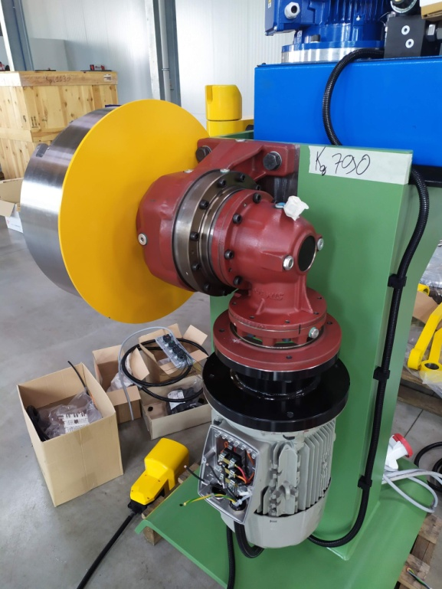

Footjog pedal

Die-holder

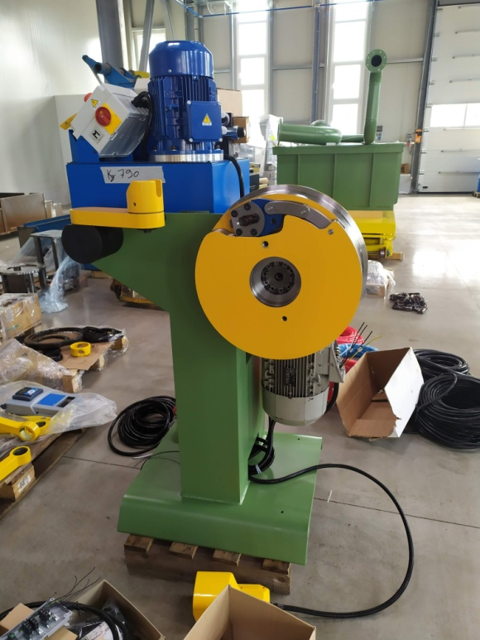

Capstan

Wire pulling pliers

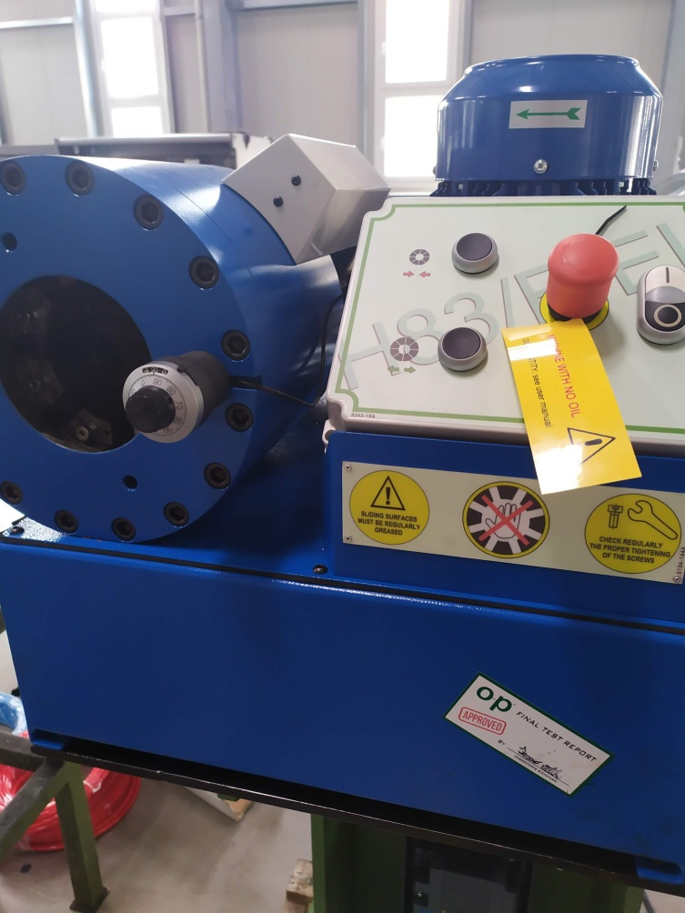

Pointing device – hydraulic press

**10 DRAWING**

|  |  |
| --- | --- |
| **Assembly Drawing** | **RIZZARDI INTERNATIONAL code** |

|  |  |
| --- | --- |
| **Point wire frame assembly drawing** | **APFRAAA** |